 | Age Related Statutory Content
EYFS | In the EYFS all areas of learning and development are important and inter-connected. Expressive arts and design is a specific area through which the prime areas are strengthened and applied. At St John’s we value individual expressions of creativity. Our focus on the process rather than purely on the product results in all children’s work not looking the same. We aim to strike a balance between adult and child led activities.  Expressive Arts and Design: The development of children’s artistic and cultural awareness supports their imagination and creativity. It is important that children have regular opportunities to engage with the arts, enabling them to explore and play with a wide range of media and materials. The quality and variety of what children see, hear and participate in is crucial for developing their understanding, self-expression, vocabulary and ability to communicate through the arts. The frequency, repetition and depth of their experiences are fundamental to their progress in interpreting and appreciating what they hear, respond to and observe. (Statutory framework for the early years foundation stage)  Expressive Arts and Design (Early Learning Goals)  Creating with Materials  Children at the expected level of development will:  - Safely use and explore a variety of materials, tools and techniques, experimenting with colour, design, texture, form and function;  - Share their creations, explaining the process they have used;  - Make use of props and materials when role playing characters in narratives and stories.  Physical Development: (Early Learning Goal)  Fine Motor Skills  Children at the expected level of development will:  Use a range of small tools, including scissors, paint brushes and cutlery
KS1 | National Curriculum KS1  Pupils should be taught:  - To use a range of materials creatively to design and make products.  - To use drawing, painting and sculpture to develop and share their ideas, experiences and imagination.  - To develop a wide range of art and design techniques in using colour, pattern, texture, line, shape, form and space  - About the work of a range of artists, craft makers & designers, describing the differences and similarities between different practices and disciplines, and making links to their own work.
KS2 | National Curriculum KS2  Pupils should be taught to develop their techniques, including their control and their use of materials, with creativity, experimentation and an increasing awareness of different kinds of art, craft and design.  Pupils should be taught:  - To create sketch books to record their observations and use them to review and revisit ideas.  - To improve their mastery of art and design techniques, including drawing, painting and sculpture with a range of materials (for example, pencil, charcoal, paint, clay)  - About great artists, architects and designers in history.
Exploring and developing ideas | EYFS  - Work from known objects and personal experiences.  - Use imagination to create simple representations of people, events and objects.  - Select and use a variety of tools to appropriately and safely combine and change media and materials.  - Explore what happens when you mix colours together. | Years 1 and 2  - Begin to collect visual information and ideas from observations, known objects, artist research, experiences and imagination – recording in sketchbooks.  - Respond to ideas and starting points by answering questions about their work.  - Work with different methods and materials as ideas develop and progress.  - Begin to select suitable materials for their task.  - Research local artists as well as artists, designers, architects and crafts makers from the past. | Years 3 and 4  - Select and record from first hand experiences, imagination and explore different materials and purposes.  - Research artists, craft makers and designers working locally as well as in different times and cultures.  - Think creatively and critically when making observations, evaluating own work and the work of others, using techniques and selecting materials and resources to use in own work.  - Begin to suggest ways to improve work.  - Develop sketchbooks and presentation of work in a variety of ways. | Years 5 and 6  - Evidence first hand observations, experiences, imaginative designs and explorations of different materials and purposes in sketch books.  - Question and evaluate own work, ideas and choices as well as the work of others.  - Make informed changes and alterations to work arising from research on artists, craft makers and designers, present day and from different times, places and cultures.  - Begin to explore possibilities and purposes, using and combining different styles and techniques.  - Present work in a variety of ways and scales.
Evaluating work | - Share work with others talking about what they like. | - Review what they have done; describing own feelings, the work they have done and the work of others e.g. annotate sketchbooks.  - Identify what they might change to better their work or develop future work. | - Compare ideas, methods and approaches in their own work and the work of others.  - Adapt work and comment on how it makes them think and feel.  - Make annotations in sketchbooks to show processes, views and opinions | - Compare ideas, methods and approaches in their own work and the work of others.  - Adapt work and comment on how it makes them think and feel.  - Make annotations in sketchbooks to show processes, views and opinions.  - Comment on how they could further develop their work.  - Develop a wide artistic/visual vocabulary and use this confidently when talking about own work and the work of others

Year Group | Skills | Progression of knowledge/skills | Key concepts of enquiry / questions and assessment opportunities | Using sketchbooks | Taking inspiration from; Artists, Craft Makers & Designers
EYFS  Nursery | Drawing | Explore different drawing media to make marks including sticks in sand and mud, tools in cornflour as well as pencils, pens, crayons and chalks.  Begin to explore scale by drawing on different surfaces including vertically on walls and easels, on the ground and on wallpaper rolls as well as on smaller areas such as paper, card, whiteboards and tablets.  Explore line and begin to understand that lines can be used to enclose a shape. Use these shapes to represent objects such as drawing a circle face with simple features or using pipe cleaners to create artworks, bending and joining them together to form a continuous line.  Begin to draw lines of different size and thickness in their art work. | Teachers should consider the main assessment in Art and Design as an on-going practice, which takes place during every art lesson through conversation with pupils.  Planning -  What resources will I need?  Monitoring -  Am I doing well? How do I know?  What am I trying to achieve?  Evaluation - How did I do? What skill did I learn? What can I change next time?  Taking inspiration from...  How do Artists create ____ using ____?  Ongoing – EYFS  Tell me about what you are making?  What might you do next?  Tell me about what you have made?  What skills are needed to use – a pen/pencil, a hand-held brush, a glue stick etc?  How do we follow simple instructions to use the equipment? (link to PD fine motor)  When I draw a person, what shapes can I use?  Tell me about the colours you can see | EYFS  (To be implemented throughout all skills)  Record WOW work in class floor book / photographs uploaded to staff drive.  Explore and experience the work of artists, craft makers and designers from different times and cultures that can inspire them.  Use some of the ideas of artists studied to create original pieces of work and notice similarities in details such as colour and shape. | Alexander Calder – continuous line drawing and wire sculpture (focus is on the use of a continuous line to create an image)
EYFS Nursery | Painting | Use paint in experimental ways including through finger painting, making patterns and representations with hands, fingers and objects such as car wheels in paint.  Discuss ideas as well as the marks made and their meanings.  Notice and talk about colour differences and different uses of colour in artwork  .  Begin to explore how colours can be changed and mixed together – working with primary colours. | What would the best colour to use be?  What happens when the colours are mixed?  How can I make a colour? |  | Amy Adele (children’s illustrator – link to seasons)  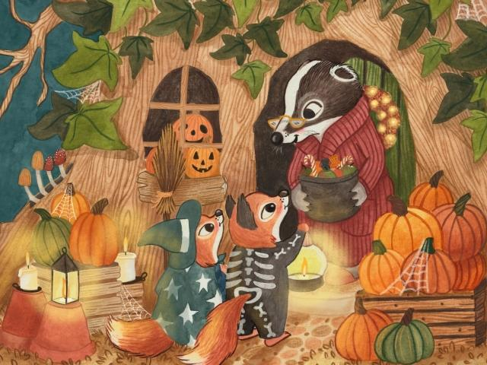
EYFS Nursery | Sculpture | Use the senses to explore a wide range of materials used for modelling including recycled and natural materials.  Manipulate materials to achieve a planned effect using plasticine, playdough or saltdough.  Use simple tools and techniques to shape, assemble and join materials with glue or tape.
EYFS Nursery | Printing | Explore making a copy of their hands, feet or fingers through printing.  Use fruit and vegetables to create simple prints and discuss what their print looks like.  Further explore printing with a range of suitable objects from the environment (man-made and natural) | What can we print with?
EYFS  Reception | Drawing | Hold a pencil effectively using the tripod grip in almost all cases, showing accuracy and care when drawing.  Show pattern and texture by adding pencil marks such as dots and lines.  Begin to use marks to express ideas about things which cannot be seen such as a loud noise, various actions and movement e.g. speed of a fast car or wind blowing.  Create simple representations of events, people and objects including features of the natural world when drawing from imagination and observation.  Develop ability to show emotion in drawings through discussing feelings, looking at photographs and art work and using this knowledge and their own ideas to represent different emotions. | Teachers should consider the main assessment in Art and Design as an on-going practice, which takes place during every art lesson through conversation with pupils.  Planning -  What resources will I need?  Monitoring -  Am I doing well? How do I know?  What am I trying to achieve?  Evaluation - How did I do? What skill did I learn? What can I change next time?  Taking inspiration from...  How do Artists create ____ using ____?  Ongoing – EYFS  Tell me about what you are making?  What might you do next?  Tell me about what you have made?  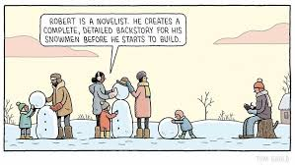  What skills are needed to use – a pen/pencil, a hand-held brush, a glue stick etc?  How do we follow simple instructions to use the equipment? (link to PD fine motor)  How does that drawing make you feel?  What do you think of it?  What shapes do I notice in this picture/object?  When I draw a person, what features does it need to have? How might I create these? | EYFS  (To be implemented throughout all skills)  Record WOW work in class floor book / photographs uploaded to staff drive.  Explore and experience the work of artists, craft makers and designers from different times and cultures that can inspire them.  Use some of the ideas of artists studied to create original pieces of work and notice similarities in details such as colour and shape. | Tom Gauld (contemporary illustrator)  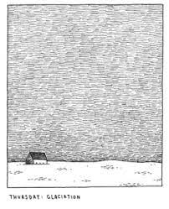
EYFS Reception | Painting | Use a range of small painting tools accurately including paint brushes.  Create simple representations of events, people and objects from imagination and observation.  Apply paint with a range of tools including fingers, sponges, and varying thickness of brushes to create a desired effect.  Continue to explore how colours can be changed and mixed together refining colour mixing skills– working with primary colours. Apply colour-mixing techniques to create and match desired colour.  Explore how mixing water affects painting e.g. use of watercolours.  Share ideas with others and work collaboratively to create and achieve a desired outcome |  |  | Angela Fehr- abstract watercolour.  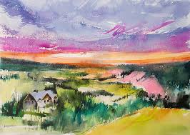
EYFS Reception | Sculpture | Refine ideas and solve problems with increasing competence and independence when creating.  Continue to develop expertise in manipulating materials to create recognisable objects and those created from imagination.  Use simple tools and techniques competently and appropriately and shape, assemble and join materials with glue or tape.  Use tools for a particular purpose with increasing accuracy e.g. to create different textures such as pencil marks in plasticine or tools to create simple decorations on a sculpture. |  |  | Barbara Reid- picture book illustrator that uses plasticine.  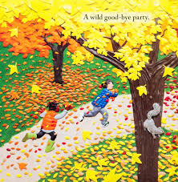
EYFS Reception | Printing | Refine printing skills demonstrating increasing independence in choice of materials and control.  Understand that a print can be created from a range of objects including those that are flat and those with raised surfaces. Explore a range of objects in their print making.  Print simple repeating patterns (e.g. 2 colours/shapes)  Press, rub, roll and stamp to make prints. | Key Stage End Point ELG  Safely use and explore a variety of materials, tools and techniques experimenting with colour, design, texture, form and function.  Confidently use a range of small tools, including scissors and paintbrushes and begin to show accuracy and care when drawing.  Share creations, explaining processes they have used.  Make use of props and materials when role playing characters in narratives and stories. |  | Jay Price (to demonstrate range of possibilities when printing)  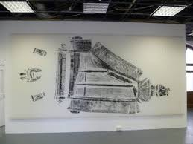  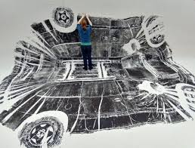
Year 1 | Drawing | Develop in confidence when using and holding a variety of tools when drawing including pencils, crayons, pastels, charcoal, chalk and felt-tip pens.  Begin to understand that different tools and materials can be used for different purposes e.g. drawing lines of different size and thickness.  Complete a simple house of elements as a point of reference throughout the year.  Show pattern and texture by adding dots and lines when drawing from observation.  Draw with increasing accuracy on smaller and larger scales. | Teachers should consider the main assessment in Art and Design as an on-going practice, which takes place during every art lesson through conversation with pupils.  Planning -  What resources will I need?  Monitoring -  Am I doing well? How do I know?  What am I trying to achieve?  Evaluation - How did I do? What skill did I learn? What can I change next time?  Taking inspiration from...  How do Artists create ____ using ____?  Ongoing – Year 1  Tell me about what you are making?  What might you do next?  Tell me about what you have made?  What patterns do I notice?  What other features/details can I add and how do I create these? | Year 1  (To be implemented throughout all skills)  Record and explore simple ideas in sketchbooks from first hand observations, experiences, and imagination.  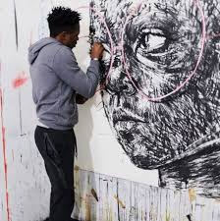  Answer questions about initial ideas and discuss how they can develop their ideas further.  Explore the differences and similarities within the work of artists, craftspeople and designers in different times and cultures. | Nelson Makamo (charcoal portrait artist)
Year 1 | Painting | Refer to colour in the house of elements and create a simple colour wheel.  Recognise and name primary colours, independently mix primary colours and match carefully to observation.  Make marks with paint using a variety of tools and techniques including the use of different brush sizes and types, using paintbrushes correctly and with increasing control.  Create washes to form backgrounds using a simple gradient wash.  Work on different scales e.g. look closely and paint a part of an object on large scale.  Explore the qualities of paint and consider the consistency when creating different textures e.g. use of glue, sawdust, sand and water.  Explore the relationship between mood and use of warm and cold colours (tones)  Make patterns in paint in the style of a specific artist. | What colours can I mix together to make a new colour?  How can I use my colour wheel to help me? |  | Jackson Pollock  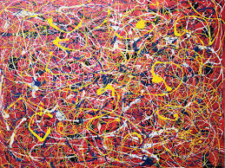
Year 1 | Sculpture | Manipulate materials in a variety of ways using clay/plasticine through rolling, pinching, cutting, twisting, scratching, coiling and add details and texture using appropriate tools.  Investigate a range of different materials and experiment with how they can be joined together to form simple structures e.g. recycled materials, man-made and natural materials.  Understand and explore 2D and 3D representations and form using a range of malleable media e.g. playdough, plasticine, clay and card. | Which tool do I need for this purpose?  Why isn’t this tool the right one?  Where does this material come from?  What natural materials can we find in our school? |  | Rebecca Hutchinson  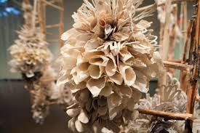  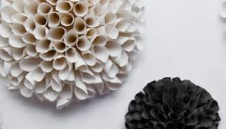
Year 1 | Printing | Make marks in print with a wider variety of objects including natural and man-made objects e.g. sponges, leaves, fruit and vegetables.  Develop controlled printing through the amount of paint applied, printing against outlines and within cut out shapes.  Use repeating and overlapping shapes to create more complex patterns building upon YR skills.  Enhance prints by adding collage using a combination of materials that are cut, torn and glued e.g. creating a stained-glass window. Sort and arrange material to create a desired effect.  Mimic prints from the environment e.g. wallpapers.  Explore different printing techniques e g. marbling. | What is printing?  What can print be used for?  What different objects can you print with?  What parts of the object are printed? |  | William Morris  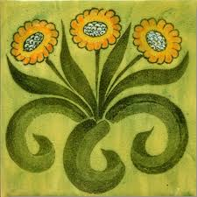
Year 2 | Drawing | Hold and use drawing tools confidently and correctly, making controlled marks from observation as well as from imagination.  Draw carefully from observation for a sustained period of time, recording shapes and beginning to position marks and features with care e.g. using a viewfinder to select a view and record what is within the selected frame.  Record ideas and observation in sketchbook to support development of ideas and skills frequently referring to visual elements of line, shape, pattern and colour through the house of elements.  Know that there are different gradients of pencil indicating how hard or soft they are which is useful when choosing which pencil to use for drawing details (HB for writing, 2B, 4B)  Learn to shade to create tone using pencils and drawing implements of different gradients. | Teachers should consider the main assessment in Art and Design as an on-going practice, which takes place during every art lesson through conversation with pupils.  Planning -  What resources will I need?  Monitoring -  Am I doing well? How do I know?  What am I trying to achieve?  Evaluation - How did I do? What skill did I learn? What can I change next time?  Taking inspiration from...  How do Artists create ____ using ____?  Ongoing – Year 2  Tell me about what you are making?  What might you do next?  Which materials might you use?  What have you discovered?  Tell me about what you have made?  What would you like to explore more of?  Are there any skills and techniques I can combine?  How did I use my pencil to create shade, tone, texture and shape? | Taking inspiration – Year 2  (To be implemented throughout all skills)  Use a sketchbook to record media explorations and simple experimentations.  Plan ideas and then design work that has been inspired by some artists studied.  Make notes on line, shape and colour used by themselves and by some artists, crafts makers and designers. | David Hockney  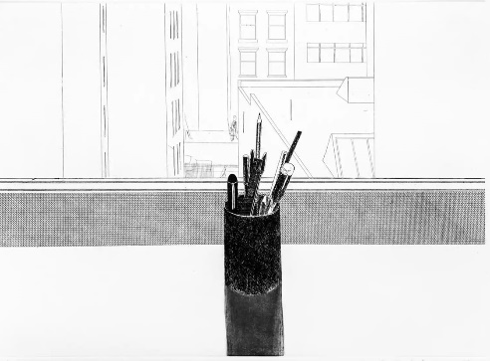
Year 2 | Painting | Continue to develop control when applying paint including layering paint, mixing media including collage, scraping paint away etc.  Experiment with making tints by adding white paint.  Experiment with making shades by adding black paint.  Experiment with water colour and colour washes, using gradient washes and variegated washes.  Begin to name different types of paint and their properties for example; watercolour, acrylic and oil paint.  Work on a range of scales. | What is the focus of the painting?  What colours were used? |  | JMW Turner  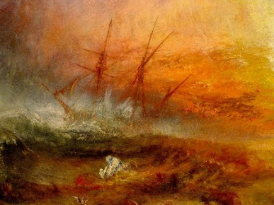
Year 2 | Sculpture | Introduce sculptures as 3D artworks based upon the artists views, preferences and style. Explore a wide range of sculptures made from different materials and on different scales.  Have an awareness of natural and man-made forms.  Continue to develop techniques from Year 1 to make 3D models using malleable materials. Understand the importance of shape, form and function when manipulating the material. Use clay to make thumb pots.  Join effectively when creating, including scoring clay and slipping before attaching.  Re-visit and replicate surface details including patterns and textures in 3D forms inspired by the work of sculptors. | What is a sculpture?  What is the job of being a sculptor and what does it involve?  What do you see?  What techniques did you use to create texture?  What materials and equipment did you use and how?  Can you remember from Year 1 where clay comes from?  How do you think people have used clay in the past? (understand that clay has been used for thousands of years and that archaeologists have used pottery to help them date sites) |  | Paul Briggs  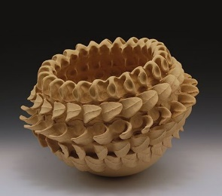  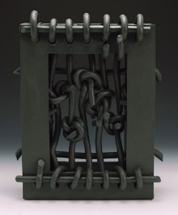
Year 2 | Printing | Use a variety of techniques to print, beginning to explore carbon printing and mono printing by marking onto an ink block, or drawing onto the back of paper on an inked block.  Apply ink to a shape or surface, experimenting with printing by pressing, rolling, rubbing or stamping.  Introduce line and tone through the use of tools at different pressures to create texture in a variety of objects e.g. sponges, leaves and fruit.  Continue developing skills using repeating or overlapping shapes to create own patterns; such as producing own wall-paper. | How is print created?  Which objects can create a print?  How can I use Styrofoam to create a block print? |  | Tracey Flynn  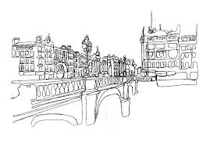
Year 3 | Drawing | Recap and continuously refer back to the elements in the house of elements.  Continue to experiment with different grades of pencil and other implements and begin to adapt angle of use to produce variations in line, texture, tone, colour, shape and pattern.  Make marks on different surfaces using techniques including hatching, cross-hatching and stippling and record in sketchbooks.  Explore the drawing of positive and negative shapes.  Begin to draw in scale, applying rules of simple perspective e.g. drawing people and faces to scale, draw your school shoe.  Confidently use a sketchbook to record visual information from different sources and support the development of a design, making refinements and alterations where necessary. | Teachers should consider the main assessment in Art and Design as an on-going practice, which takes place during every art lesson through conversation with pupils.  Planning -  What resources will I need?  Monitoring -  Am I doing well? How do I know?  What am I trying to achieve?  Evaluation -  How did I do? What skill did I learn? What would I change/do differently? How can I improve this? What have you discovered? How do you feel about the end result?  Taking inspiration from...  How do Artists create ____ using ____? What do I notice about this piece of Art work? What materials or tools did the Artist use? Why did the artist use this technique? What does the image make you think or feel?  Ongoing – Year 3  What do I want to represent/create?  What do I already know that could help me?  What tools and materials do I need? Why? What techniques can I use to complete or enhance my work?  What features do I notice and recognise in this person, character, place, object, animal, building or scene?  How can I recreate this? | Taking Inspiration – Year 3  (To be implemented throughout all skills)  Replicate some of the techniques used by notable artists, crafts makers and designers and record in your sketchbook.  Plan, develop and create original pieces that are influenced by studies of others.  Begin to make notes of techniques used by themselves and others and evaluate artwork. | Luke Adam Hawker  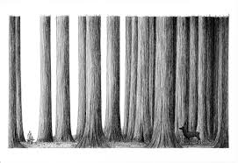
Year 3 | Painting | Confidently use colour wheels when mixing colours and label the process that has happened – which colours were mixed and which colours were made?  Apply colour using dotting, scratching and splashing.  Independently select different types of brushes for a particular purpose.  Create observational, portrait and landscape paintings thinking about the foreground, middle ground and background.  Combine previous knowledge on colour washes using gradient washes, variegated washes and introduce blotting. Use perspective and scale to paint accurately.  Begin to explore and paint in the style of a particular artist and style e.g., abstract, impressionist etc  Think about abstract ways to show own ideas and feelings using a variety of materials such as; paint, paper, paint resist.  . | What sort of colours and techniques did you use?  What technique did you find most effective and why? |  | Claude Monet and other impressionist painters.  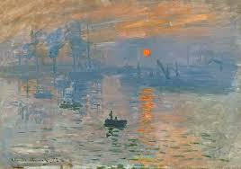
Year 3 | Sculpture | Shape, form, model and construct malleable and rigid materials confidently and independently.  Introduce carving, moulding and shaping (coiled form) to create your own finished product.  Build upon Y1 and Y2 sculpting techniques to convey movement and texture adding decorative details where appropriate. | How can different effects be created for e.g. fur, scales, texture, hair, clothing?  What different ways can you use this material/tool? |  | Malene Barnett  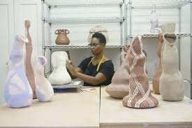
Year 3 | Printing | Use layers of 2 or more colours when printing – introduce and explore relief printing techniques.  Make own printing blocks; using coiled string glued to a block.  Make precise repeated patterns to create a desired effect using a variety of printing methods including block printing, use of a roller and slab, plasticine, stamps and sponges.  Talk about the processes used to produce a simple print and record in sketchbook. | What are some of the features of this print pattern?  What techniques have been used in creating this print?  How effective are the techniques? |  | Orla Kiely  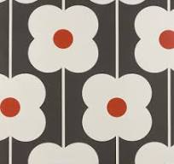
Year 4 | Drawing | Confidently and regularly use sketchbook to annotate sketches, explain ideas and express feelings.  Confidently use a wider range of different grades of pencil and adapt the angle of use to show line, tone, texture, light and shadow.  Draw with increasing accuracy using a variety of tools and surfaces – paint, chalk, pastel, pen and ink to focus on the elements of line and form.  Include increased detail within work, working from careful observation and ensuring perspective to give the right impression of height, width, depth and placement. | Teachers should consider the main assessment in Art and Design as an on-going practice, which takes place during every art lesson through conversation with pupils.  Planning -  What resources will I need?  Monitoring -  Am I doing well? How do I know?  What am I trying to achieve?  Evaluation - How did I do? What skill did I learn? What can I change next time?  Taking inspiration from...  How do Artists create ____ using ____?  Ongoing – Year 4  Tell me about what you are making and what inspired you?  What might you do next?  What have you discovered?  How do you feel about the end result?  Tell me about things you really liked or enjoyed?  What would you like to explore more of? | Taking Inspiration – Year 4  (To be implemented throughout all skills)  Use a sketch book to record media explorations and experimentations as well as try out ideas and plan colours and collect source material. Replicate some of the techniques used by notable artists, craftspeople and designers.  Create original pieces that are influenced by the studies of others.  Compare ideas, methods and approaches in their own work and the work of others.  Adapt and refine work to develop it further. | MC Escher  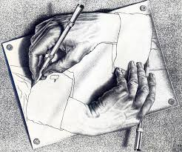
Year 4 | Painting | Continue to mix colours confidently and link back to the colour wheel.  Experiment with creating mood using colour and record findings in sketchbooks.  Make light and dark tones using black and white paint.  Use several learnt techniques e.g., stipple, flick, graded wash, variegated wash, blotting and introduce wax resist technique.  Recognise the work of certain artists by their style (recalling Impressionism from Y3) and introducing Cubism.  Produce work influenced by a particular artist and evaluate the techniques used.  Produce a final image on a new medium – canvas. | What is Cubism?  How do you feel about the artwork?  What techniques could you use to recreate this picture?  What techniques will you use for your own painting? |  | Paul Klee  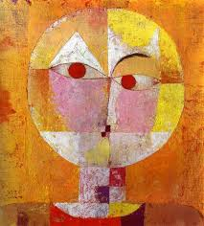
Year 4 | Sculpture | Continue to plan, design, make and adapt models independently.  Make informed choices giving reasons when demonstrating shape, space and form.  Confidently discuss own work and work of other sculptors and architects using key vocabulary appropriately.  Build upon knowledge and skills from Year 3 using sculpting techniques (slab) to convey movement and texture adding decorative details to create a planned effect.  Experience surface patterns/textures using learnt techniques. | Tell me about the materials and techniques you are using and what influenced your choices.  How successful were you in achieving your planned effect? |  | Magdalene Odundo  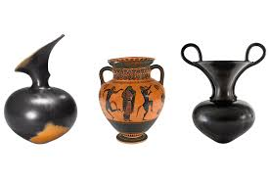
Year 4 | Printing | Research, create and refine a print using a variety of learnt techniques revisiting some previous printing techniques including marbling, block printing and mono printing.  Blend two colours when printing using layering of paint.  Combine a variety of materials of differing texture to create a collagraph. |  |  | Katsushika Hokusai  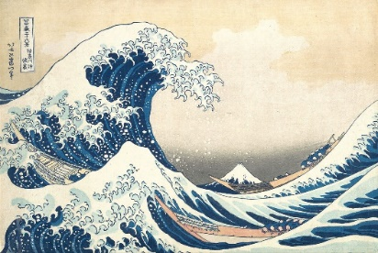
Year 5 | Drawing | Refer back to the house of elements frequently and evaluate work using correct art vocabulary.  Use mapping skills to develop further awareness of scale when drawing (possible local links include Canterbury Cathedral and local coastlines)  Focus on drawing from a specific viewpoint, angle, and perspective. Look at the line of vision, focal point and banishing line. Explore methods to support this type of drawing and record in sketchbook.  Experiment with shading to create a 3D effect by further exploring the properties of line, tone, pattern, texture, colour and shape. Make choices about pencil gradient and shading techniques to achieve the desired effect. | Teachers should consider the main assessment in Art and Design as an on-going practice, which takes place during every art lesson through conversation with pupils.  Planning -  What do I already know? What tools and materials do I need? Which tools and materials are the most suitable for my project? What techniques can I use to complete or adapt/enhance my work? • How can I create an effect?  Monitoring -  Am I doing well? How do I know? What am I trying to achieve?  Evaluation -  What does this material make me think of? What could I use it to represent? How would/could I improve this? What would I change/do differently? What skills do I want to improve? What different ways can I find to use this material/tool?  Taking inspiration from...  What do I already know that could help me? How do Artists create ____ using ____? What do I notice about this piece of art work? What materials and tools did the artist use? How does this technique work?  Ongoing – Year 5  Tell me about what you are making and what inspired you?  What might you do next?  Tell me about the materials and techniques you are using.  What have you discovered?  How do you feel about the end result?  What kinds of problems did you encounter and how did you get around them?  Tell me about things you really liked or enjoyed. | Taking Inspiration – Year 5  (To be implemented throughout all skills)  Use sketch books to collect and record visual information from a wide range of sources and begin to reflect upon ideas.  Discuss style of some notable artists, craftspeople, and designers – document in sketchbooks using more detailed notes.  Create original pieces that show a range of influences and styles informed by own research, exploration and experimentation with techniques, materials and media.  Analyse and express feelings based on own work and the work of others. | Dennis Creffield  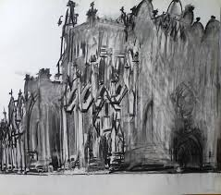
Year 5 | Painting | Build on previous work with colour by exploring intensity and saturation.  Develop watercolour techniques learned previously and build on wax resist. Introduce using salt and using dry brush.  Develop fine brush strokes.  Demonstrate secure knowledge about primary and secondary, warm and cold, complementary and contrasting colours.  Test media and materials and document findings in sketchbooks.  Create imaginative work informed by research.  Create a colour palette and explore using limited colour palettes. | What do you think of this picture?  What does this image make you think/feel?  What media has been used for this artwork?  What is Surrealism? |  | Salvador Dali  Surrealism  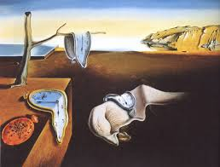
Year 5 | Sculpture | Describe the different techniques involved in modelling, sculpture and construction.  Make considered choices between or using a combination of thumb, coil, slab techniques to make a sculpture.  Introduce scale and using both small and large scale, plan, design and create a sculpture, documenting preparatory work in sketchbooks. | What is the purpose of sculpture?  What processes/techniques would be most useful for different purposes?  What materials/tools could I use and what might influence my choices?  Explain choices made using correct vocabulary. |  | Koike Shôko  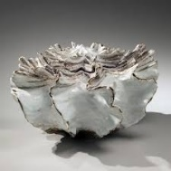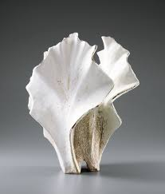
Year 5 | Printing | Revisit and further explore the technique of Mono printing, overlapping prints and the process of building images.  Design and create motifs to be turned into printing blocks.  Investigate techniques from paper printing to work on fabrics.  Introduce and explore Intaglio using thick cardboard etched with sharp pencil point.  Using Y5 vocabulary, discuss and evaluate own work and the work of others in sketchbooks. | What is the first step I need to explore?  What comes next?  What else could I try? |  | Elizabeth Blackwell  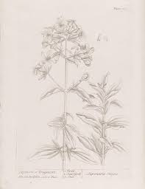
Year 6 | Drawing | Demonstrate a wide variety of ways to make marks on dry (paper, canvas, card) and wet media (watercolour, prints, clay).  Identify and discuss notable Artists who have worked in a similar way to their own work, developing ideas and document the processes in sketchbooks.  Continue to experiment with the elements of art; line, tone, pattern, texture, form, space and shape to create botanical drawings.  Choose a style of drawing suitable for own work e.g. realistic, impressionistic.  Revisit and further develop drawing skills working on viewpoint, distance, direction, angle, vanishing line, line of vision, techniques to show movement – preparatory sketches to be evaluated in sketchbooks.  Learn how to add effects such as reflections, direction of sunlight and shadow. | Teachers should consider the main assessment in Art and Design as an on-going practice, which takes place during every art lesson through conversation with pupils.  Planning -  What do I already know? What tools and materials do I need? Which tools and materials are the most suitable for my project? What techniques can I use to complete or adapt/enhance my work? • How can I create an effect?  Monitoring -  Am I doing well? How do I know? What am I trying to achieve?  Evaluation -  What does this material make me think of? What could I use it to represent? How would/could I improve this? What would I change/do differently? What skills do I want to improve? What different ways can I find to use this material/tool?  Taking inspiration from...  What do I already know that could help me? How do Artists create ____ using ____? What do I notice about this piece of art work? What materials and tools did the artist use? How does this technique work?  Ongoing – Year 5  Tell me about what you are making and what inspired you?  What might you do next?  Tell me about the materials and techniques you are using?  What have you discovered? How do you feel about the end result?  What kinds of problems did you encounter and how did you get round them?  Tell me about things you really liked or enjoyed?  Describe in detail the features and effects identified in artwork.  How can I recreate this? | Taking Inspiration – Year 6  (To be implemented throughout all skills)  Engage in open ended research about a focus artist, using a sketchbook to gather ideas and to generate questions to explore. Independently refine technical skills in order to improve their use of materials and techniques.  Be able to explore possibilities, using and combining different styles and techniques.  Improve the quality of sketchbook work with mixed media work and annotations – including more detailed notes, including feelings and opinions about the work and drawing techniques of famous artists, themselves and their peers work.  Produces original pieces showing a range of influences and styles. | Charles Darwin  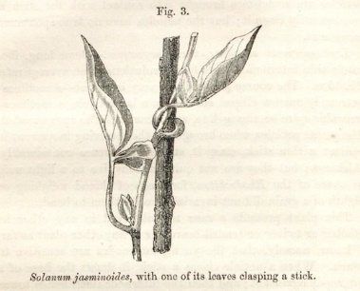
Year 6 | Painting | Use appropriate paint, paper and implements to adapt and extend their work.  Carry out initial studies, test media and materials.  Work from a variety of sources included those researched independently.  Build up layers of paint and then explore ways to add fine detail.  Show an awareness of how paintings are created (composition.)  Explore the use of colour for particular purposes, emotions, moods and atmosphere.  Understand and use the terms hue, tint, tone and shade when discussing and evaluating work. | What colours are used?  Does the image elicit any strong feelings and emotions? What do you think of it?  Where did you find out information about the artist or movement?  What key pieces of information can you share about the artist? Were they part of a movement?  Are there any similarities in the artwork produced by this artist and another researched by someone else? |  | A variety of autobiographical artists based upon their own research.  Teacher to use example of Robert Rauschenberg  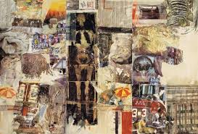
Year 6 | Sculpture | Confidently use own ideas and knowledge of sculpture during the planning and designing process and describe processes used.  Using previously learnt techniques (thumb pots, coiling, slab work) incorporating a range of media and materials and knowledge of inspirational sculptors, use their own interpretations, creative and personal thoughts and feelings to create a piece of work. | What processes/techniques would be useful?  What materials/tools could I use?  Who has inspired you?  How would you describe your own personal style? |  | Hannah Simpson
Year 6 | Printing | Develop knowledge of printmaking processes by comparing intaglio printing technique (Y5) with relief printing, comparing the different methods, approaches and effects of both. Introduce lino-cutting as a form of relief printing.  Create more intricate and detailed designs through control of line, shape, texture and tone when printing.  Build up drawings, designs and images in sketchbooks of whole items or parts of items using various techniques. | What is the first step I need to explore?  What comes next? What else could I try? |  | Elizabeth Catlett
Local Artists and Local Links
Canterbury Festival – Opening Parade Canterbury Cathedral Animate Arts Pilgrims Hospice The Beaney Museum Espressions Arts The King’s School

Art & Design Key Vocabulary
Nursery | Year R | Year 1 | Year 2 | Year 3 | Year 4 | Year 5 | Year 6
Pencil, pen, chalk, crayon, paintbrush, draw, drawing, paint, painting, print, model, line, wavy, straight, shape, colour, mix, scissors, cut, glue, tape | Roll, knead, tear, join, material, thick, thin, sponge, artist, pastel, illustration, colour mixing, pattern, press, rub, roll, stamp, decorate | Pastels, charcoal, felt-tip pens, primary colours, repeat, overlap, marble, rubbings, stencil, collage, details, texture, mood, warm, cold, tone, wash, colour wheel, clay, plasticine, pinch, twist, scratch, coil, 2D (flat) 3D,  House of Elements | Observe, elements, shade, blend, layering, brush strokes, media, watercolour, acrylic, oil paint, natural material, man-made material, viewfinder, scraping, secondary colours, tints, shades, gradient wash, background, form, function, score, carbon printing, mono printing, ink, gallery, designer, sculptor, sculpture, craft maker, architect, sketch, sketchbook | Paint resist, grades of pencil, variations, hatching, cross-hatching, stipple, positive shapes, negative shapes, scale, perspective, dotting, scratching, splashing, portrait, landscape, features, foreground, middle ground, blotting, horizontal, vertical, contrast, opaque, translucent, transparent, symmetry, asymmetrical, symmetrical, style, carving, moulding, shaping, coils, printing block, Impressionism | Shadow, proportion, placement, surface, flick, wax resist, abstract, canvas, slabs, slips, corrugated, collagraph, monochromatic colour, silhouette, Cubism | Viewpoint, angle, line of vision, focal point, banishing line, imagery, complementary, contrasting colours, hue,  intensity, saturation, colour palette, vivid, muted, malleable, depth, Intaglio, motif, Surrealism | Visual, tactile, distance, direction, effects, reflections, atmosphere, technique,

